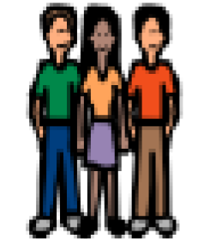 | At recess and in my class there are lots of kids I can play with.
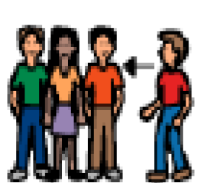 | When I want to play with someone I need to do these things: First I look at the person’s face.
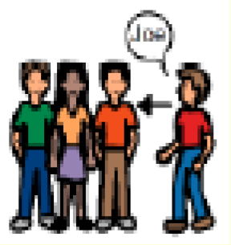 | Next I say their name to get their attention.
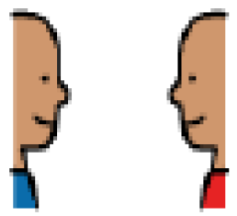 | I wait until that person looks back at me.

