- Quietly go to the calming area and set the timer for 5 minutes. Sit down on the bean bag.
- Count to 10 slowly. Then count backward from 10 slowly.
- Take 10 slow deep breaths.
- Get paper and colored pencils from the shelf.
- Write and draw about your feelings or ideas.
- Read or listen to a book on tape.
- Use a deck of cards until I feel calm.
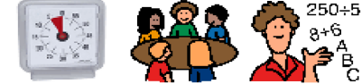
- When the time is up, ask myself “Am I calm enough to return to my group and follow the teacher’s directions?”
- If my answer is “No”, continue writing, drawing, reading, listening or using the deck of cards for five more minutes.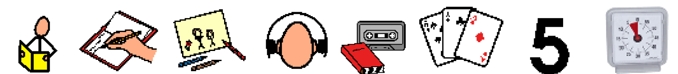
- If my answer is “Yes,” I will quietly return to my classroom and follow my teacher’s directions.
- Pat myself on the back for using my Calming Area and Strategies and not losing control!

