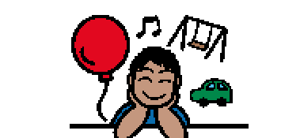 | Sometimes people like to do things that make them feel good. Like playing with their favorite toy or eating their favorite food. Sometimes people do things make them feel calm. Some things are good for people, and some are not good for people. A lot of times these things are called habits. Habits are the things people do over and over.
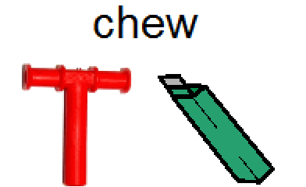 | People don’t even realize they have a habit, sometimes like when people have a habit of chewing their fingernails. Some people grind their teeth. It is not a good habit for people to grind their teeth or chew their nails. It is important to try to find a tool that will help people to not hurt their nails or teeth, like using a chewy tube or gum or chewelry.
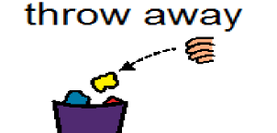  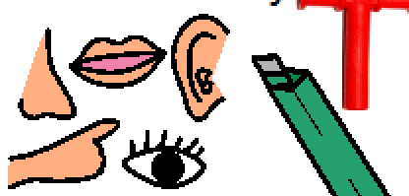 | When students chew gum at school, they try to remember to follow the rules. If students need to chew gum at school, they can ask their teacher. They should only chew gum when their teacher says it is okay. They try to remember not to blow bubbles or take the gum out of their mouth. When they are finished chewing gum, they put the gum in the trash can. It is important to remember not to throw gum on the floor or put it on a desk, because it will make a mess. Chewing gum is a sensory tool that helps people stay calm.

