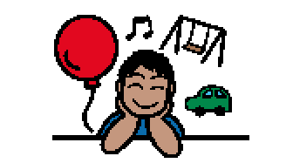 | Sometimes people like to do things that make them feel good, like playing with their favorite toy or eating their favorite food. Sometimes people do things that make them feel calm. Some things are good for people, and some are not good for people. A lot of times these things are called habits. Habits are the things people do over and over.
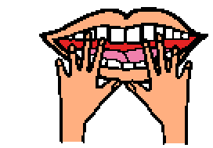  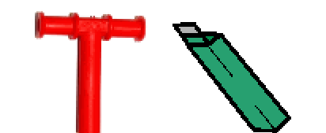 | People don’t even realize they have a habit, sometimes like when habit of chewing their fingernails or when people chew gum. Some people grind their teeth. It is not a good idea for people to grind their teeth or chew their nails. It is important to try to find a tool that will help people is not hurt their nails or teeth, like using a chewy tube or gum or chewlry.
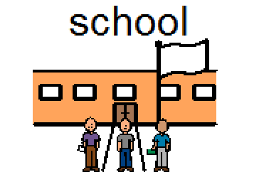  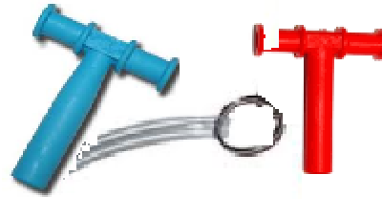 | There are some times when gum is not a choice like at some schools. A chewy tube is a special tool that can be used at school. People can bite and chew on a chewy tube. Chewy tubes can be attached to a hook to carry. Chewy tubes can stay in a special box or carrying bag. It is important to keep a chewy tubes clean. It can feel good to chew and stay calm.

