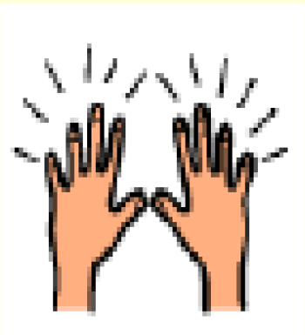 | It is very important to have clean hands.
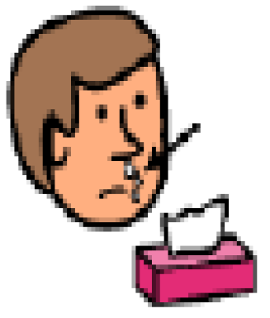 | When my nose is runny I will try to use a tissue.
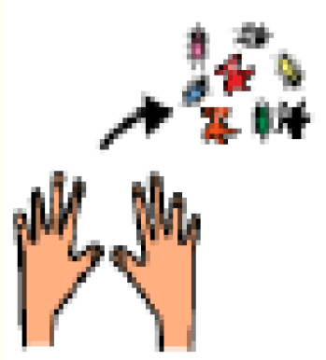 | Using a tissue will keep the germs off my hands.
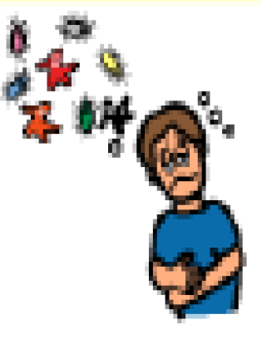 | There are lots of germs on my hands and germs can make people sick. This makes them sad.
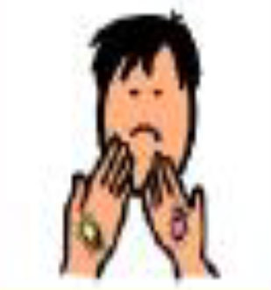 | When I put my fingers in my mouth they get lots of germs on them.
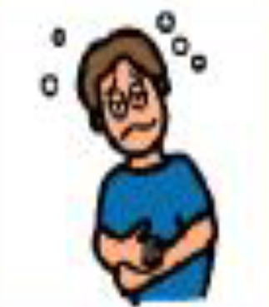 | This might make people sick too.
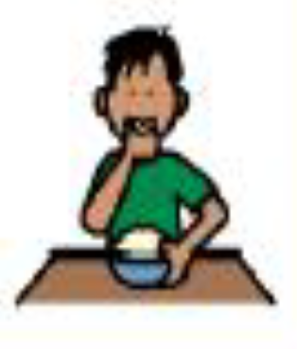 | When I eat food my hands get germs on them.
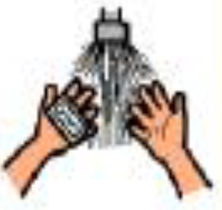 | Before and after I eat I will try to wash my hands.
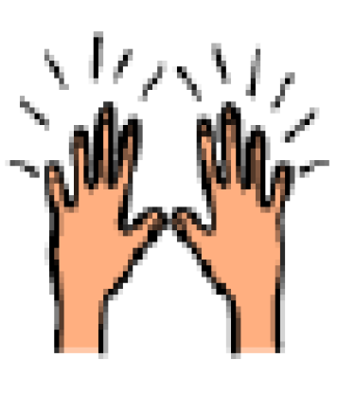 | My hands will be clean with NO germs.
 | This will make people happy.

