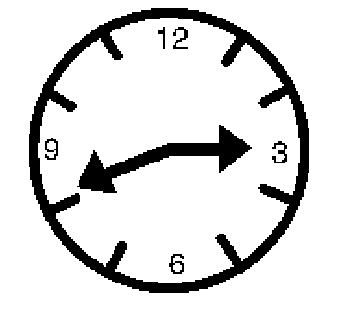 | Daylight Saving Time happens every spring and fall. We set our clocks ahead one hour in the spring. We set our clocks back one hour in the fall.
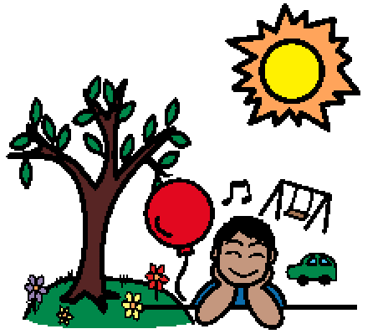 | We change our clocks to have more sunlight at night in spring to have a longer day. This gives us more time to play and enjoy the nice weather outside.
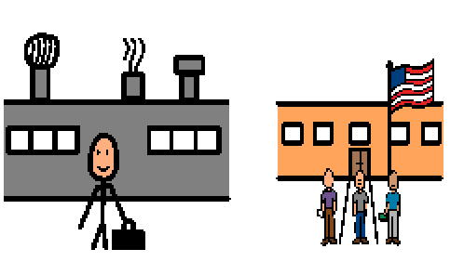 | We also change our clocks to have more sunlight in the morning in the fall for school and work.
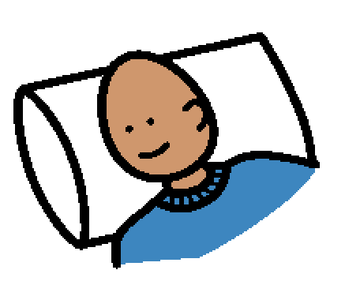 | People might feel sleepy in the mornings or awake at night, but they need to try go to sleep at night at the same time. It may take a few days to adjust to the change.

