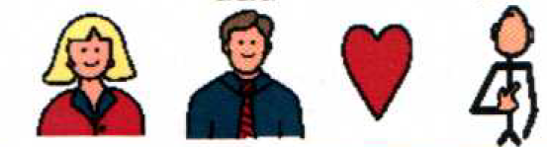 | My mom and dad love me.
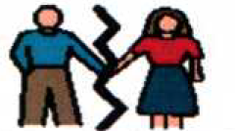 | My mom and dad have a hard time getting along. They are divorced.
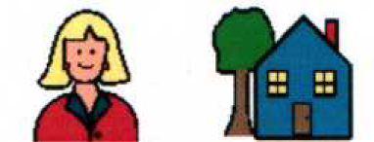 | My mom lives in one house. Sometimes I live with her.
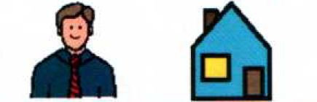 | My dad lives in another house. Sometimes I live with him.
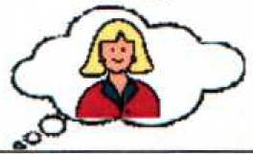 | There are times I will miss my mom.
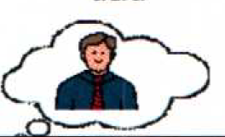 | There are times I will miss my dad.
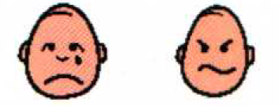 | Sometimes I will be sad or mad. It is OK to be sad or mad.
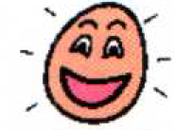 | I will be happy again soon.
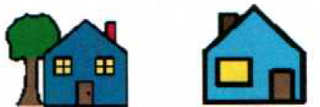 | Now I have 2 houses.
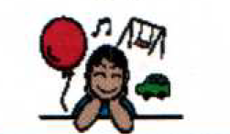 | I can have fun at both houses!
 | My mom and dad both still love me.
 | It will be OK!

