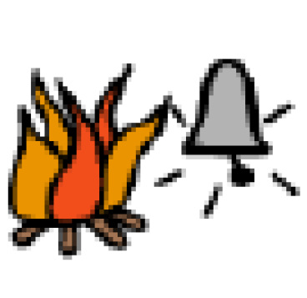 | Sometimes our school has fire drills. Fire drills are practice in case there is a fire in our school.
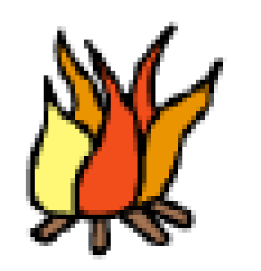 | Fire drills are not real fires.
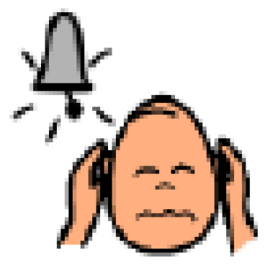 | A loud bell will ring to start the fire drill. Sometimes people will cover their ears.
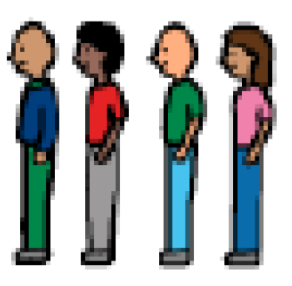 | I will get in line when the fire drill bell rings.

