First Then Picture Schedule
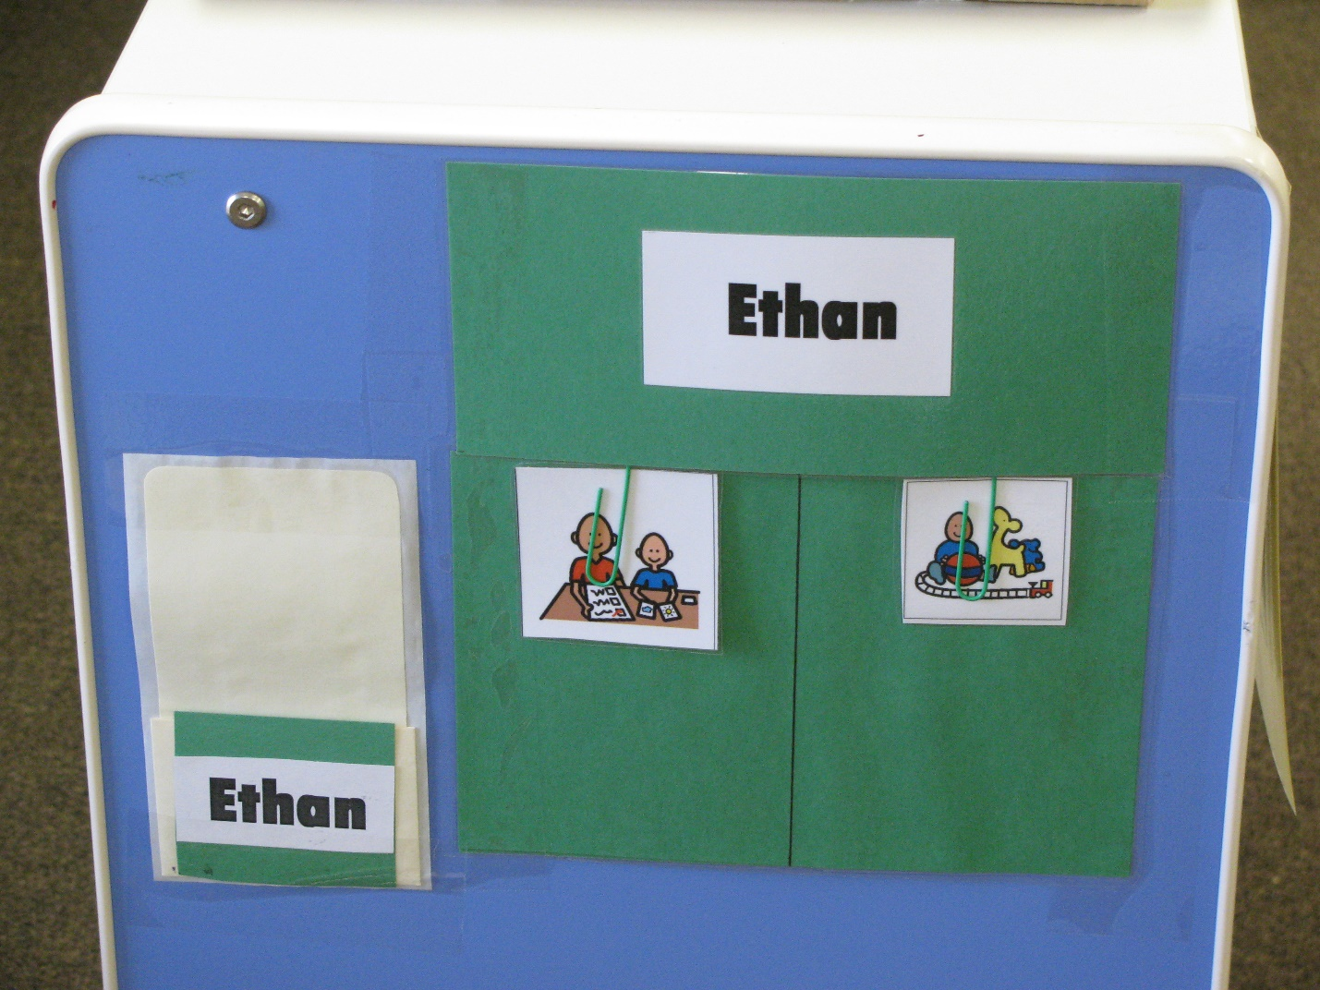
Category: Schedules
Description: Student is handed his name card that he matches and places in the pocket on his schedule. He then takes the picture on the left and matches it to an identical one in the area he is going. Repeat procedure for next picture. Function: independent transitioning.

