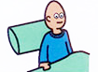 | I get up
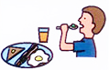 | I eat breakfast
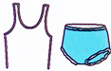 | I put on my underwear
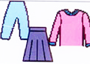 | I put on my clothes
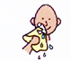 | I wash my face
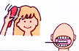 | I brush my hair, then I brush my teeth
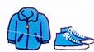 | I put on my coat and shoes

