 | When a person dies, their family may have a visitation. A visitation is a special event where people go to say goodbye to someone who has died. Sometimes a visitation is called a wake. My special person died and I am going to a visitation.
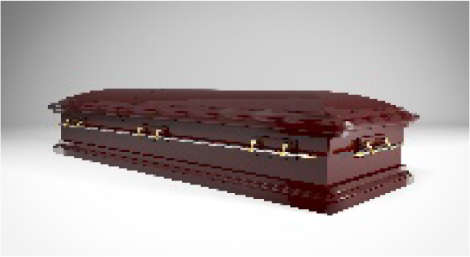 | My special person who died may be lying in a casket. A casket is a special box for people who have died. I know that my special person is dead. Their body stopped working. They cannot see, hear, or feel anything.
 | At a visitation, some people walk by the casket. Some people hug and talk to family members of the dead person and say, “I am sorry” or “I am sorry for your loss.”
 | At the visitation, people will be sad and they might cry. I maybe sad and cry. That is OK. If I am having a hard time, I can tell my mom, dad or favorite adult. They will help me.
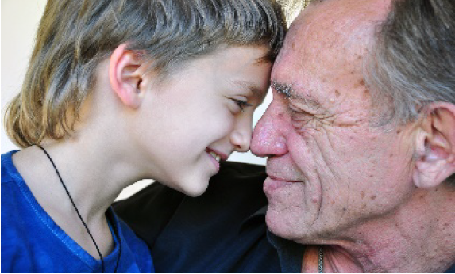 | I can think of the fun times I had with my special person. Soon I will feel better and be happy again. I know my special person will always love me and I will always love them.

