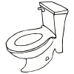 | I go to the bathroom every day. I go to the bathroom when I have to go pee or poop in the toilet. Some people call this going “potty.” Some people call going to the bathroom going “Number 1” to pee or “Number 2” to poop. I know I have to go when my body feels full and is ready to pee or poop.
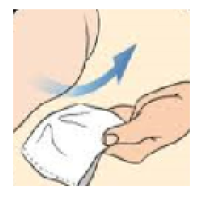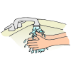 | I use the toilet paper to clean myself. I remember to wipe from front to back with toilet paper. I check the toilet paper to see if it is clean. I put the dirty toilet paper in the toilet and get more if it is not clean. When the toilet paper is clean after I wipe, I am finished wiping. I put the toilet paper that I used in the toilet. I wash my hands until they are clean before I leave the bathroom. Then, I can finish what I was doing before I had to go to the bathroom.
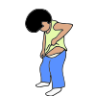 | Sometimes I need to go to the bathroom when I am busy. I should stop what I am doing and go, so I don’t have an accident in my pants. I try not to make a mess in my clothes or have an accident with pee and poop. Even when I am busy or playing and having fun, I need to remember to take a break so I can go to the bathroom and use the toilet.

