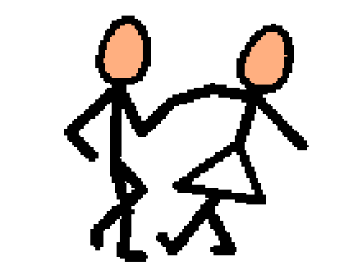 | There are special dances and events at school. Some schools have dances and events for holidays. Some schools have dances and events for Homecoming. Some schools have a special dance called prom. Prom is a dance for high school students. Usually prom is for juniors, or 11th grade students, and seniors, or 12th grade students. Sometimes students go alone to prom, sometimes they take a date. Sometimes students go in groups with their friends.
 | Prom is sometimes semi-formal and sometimes formal. This means that students wear suits or tuxes and dresses. Usually, the girls wear dresses, but some might wear dress pants. Most of boys wear tuxes or suits. If a boy asks a girl to prom, he usually will give her a special flower to wear. These are called corsages, and they are worn on the wrist. The girl usually gives the boy a matching flower that is worn on his suit-jacket. This is called a boutonniere. If two people go to prom together, they have to decide what they will wear, so they can match the colors in their clothes and flowers.
 | There are usually a lot of pictures taken before and at prom. The photographer at prom takes pictures of groups of friends and couples. There is usually music, and a lot of students will dance and have fun. There is usually a special prom theme and song too. Sometimes there is food at prom, and sometimes groups go out to eat before prom. Sometimes students rent limos or drive a special car. Most students plan for weeks and months ahead about where they are going and about how they are going to get to prom. Most parents can help students figure out what to do to get ready for prom.
 | There are special awards given to students that are chosen as Prom King and Queen by the other students attending prom. The Prom King and Queen get to wear special crowns when they win. Most schools have an after-prom party. This party might be late that night, after prom is over. Sometimes the after prom is the day after and is at another place or at the school. Prom is fun celebration for high school students. It can be fun to dress up and go out with friends.

