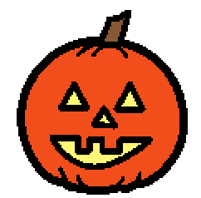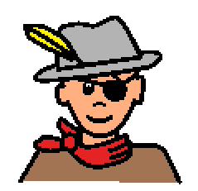 | Halloween is on October 31st. Halloween is a holiday or a celebration. There are fun things to do on Halloween. Sometimes people celebrate Halloween on days before Halloween. Some people don’t celebrate Halloween.
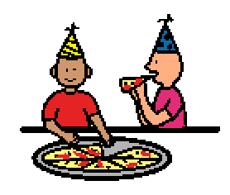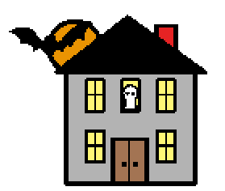 | Some people go out to eat. Some people stay home with their families. Some people like to dress in costumes. Some people have parties. Some go to haunted houses and like to be scared. Some people have special treats and candies.
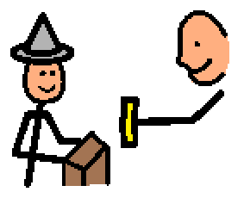 | Sometimes children go trick-or-treating, and they walk around to get candy. An adult or old child may help children know where to go. The candy should be checked by an adult, like mom or dad, first. Then children get to eat the candy they were given. Halloween can be a lot of fun!

