Shoes  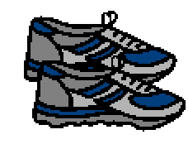 | People wear shoes to protect their feet. Shoes keep feet dry and healthy and safe. Shoes keep feet safe from rocks and sharp things on the ground.
Feet  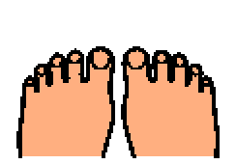 | Shoes help people have healthy feet. Sometimes shoes are uncomfortable. When shoes are uncomfortable, people want to take their shoes off.
School  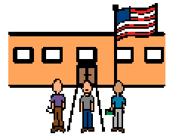 | It is important to remember that people should keep their shoes on when they are in public place, like at a restaurant or the mall. Shoes have to stay on your feet at school too.
Shoes on  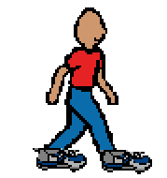 | Shoes protect feet at school. It is important to have shoes on in class, at PE, and at recess unless the teacher asks students to take their shoes off, like for swimming or gymnastics.
Fire drill  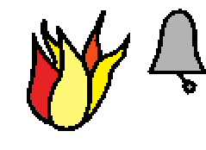 | During drills, like a fire drill students need to have their shoes on so that they can safety and quickly exit the building. There is not time to put shoes on during a drill.
Comfortable  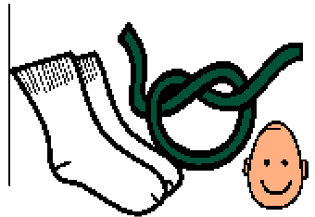 | If shoes are hurting or very uncomfortable, people should try wearing a different pair of shoes or softer socks to be more comfortable. It may help to loosen the shoelaces a little bit. Teachers and parents can help.
Tell adult  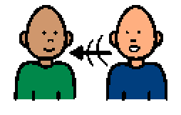 | It is a good idea to tell teachers and parents so they know if shoes are uncomfortable. It is good to remember that shoes are supposed to be on at school and in public places to keep feet healthy and safe.

