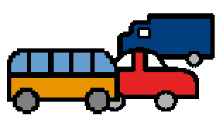 | When I ride to school. I ride in a car or a bus. Some students ride in a car. Some students ride in a bus.
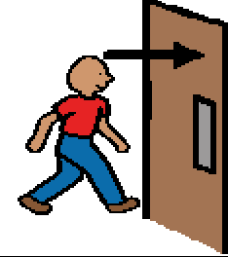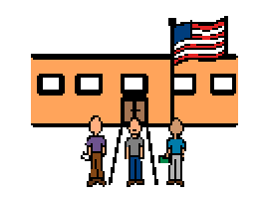 | When I get to my school, I go inside. Other students are going to classes, too. We walk to our classes and get ready for the day.
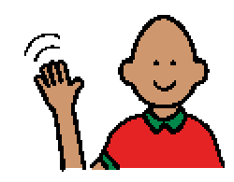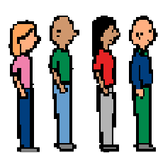 | Some students say “Hi!”and talk when walking. Some say “Good morning!” Some walk quietly to their classroom.
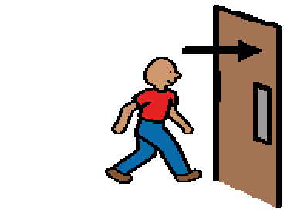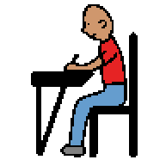 | I walk to my classroom, and I go inside I put my things away and get ready to learn. I get ready for my day.
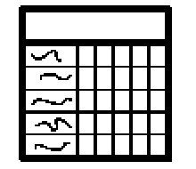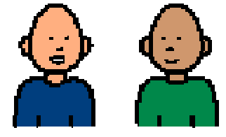 | I remember to check my schedule. I listen to my teacher and adults. My teacher is happy to see me.
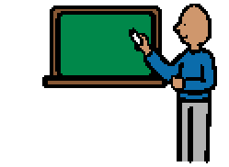 | My teacher likes it when I am ready to learn. My parents are proud of me, too.

