Left to Right Work System
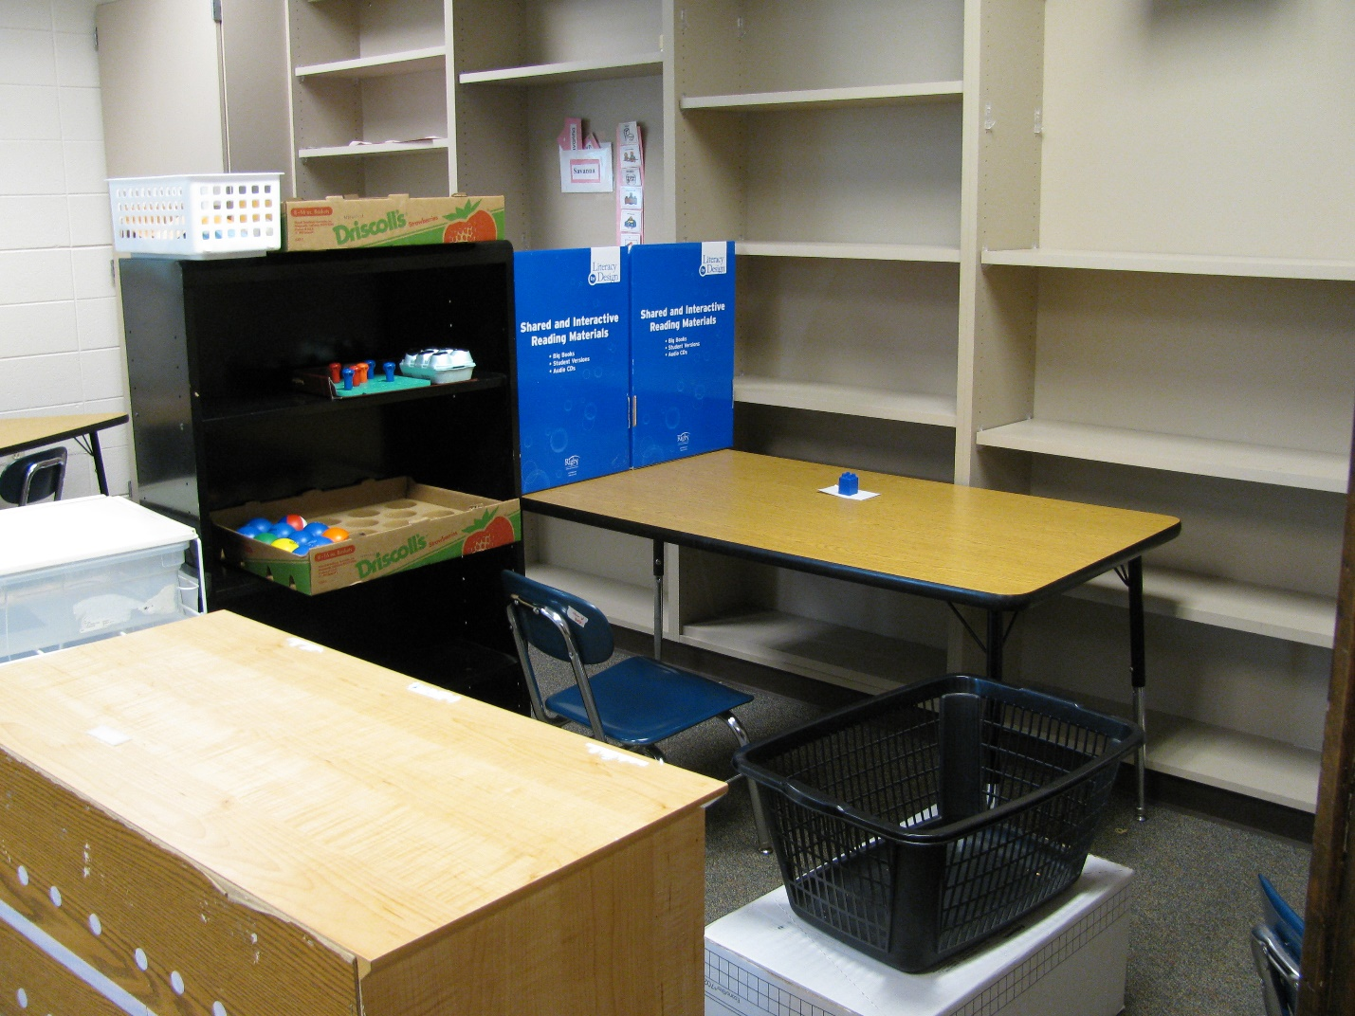
Category: Work Systems
Description: Activities to be completed are placed on student’s left. Student completes them and puts them in ‘finished’ box on his right. Area is screened to prevent distractions during independent work time.

