Lego Activity Basic Big Little
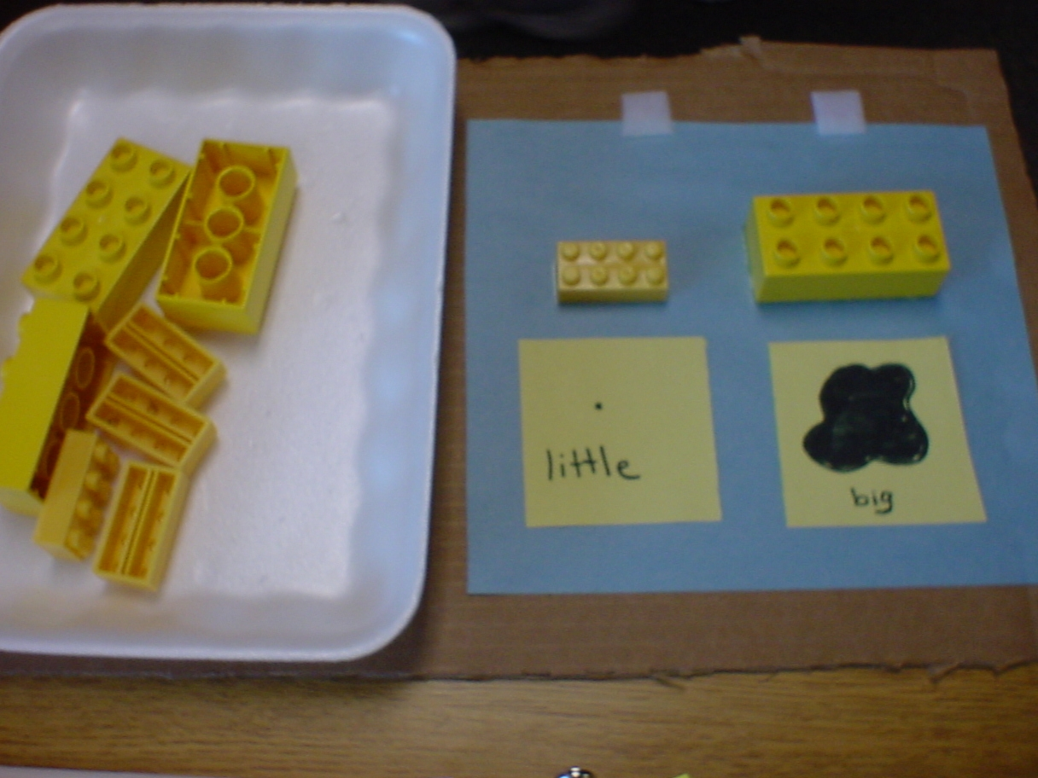
Category: Structured Tasks
Description: Styrofoam tray and lego pieces are glued to cardboard base. Student sorts legos by stacking them on top of the 2 glued pieces. Function: independent leisure skill.

