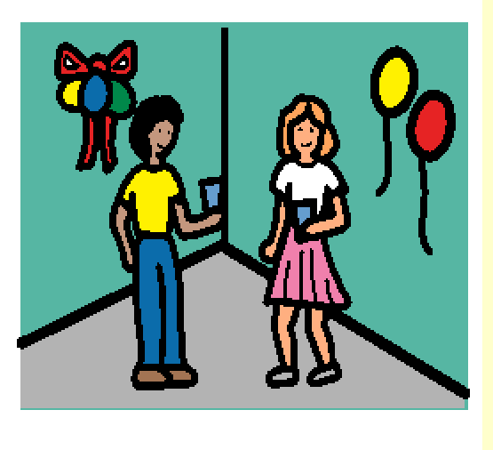 | I will have a birthday party. Children will come to my party.
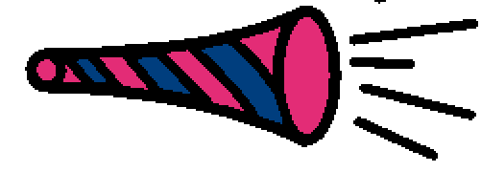 | They will say, “Happy Birthday ” to me.
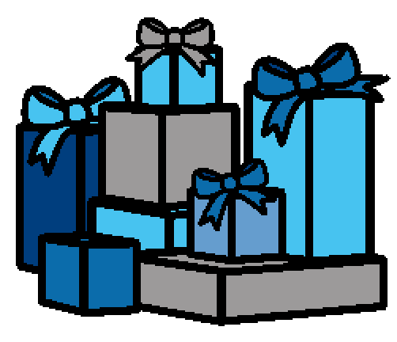 | They will bring presents that I can open after we eat birthday cake.
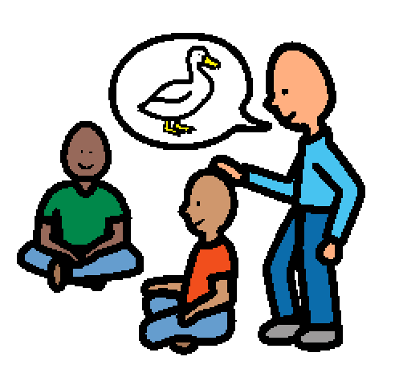 | We will play games at my party.
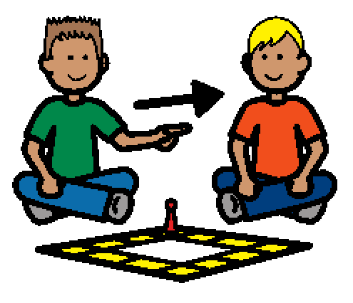 | I will take turns and let my friends play, too.
 | Some of the children will get prizes if they win a game.
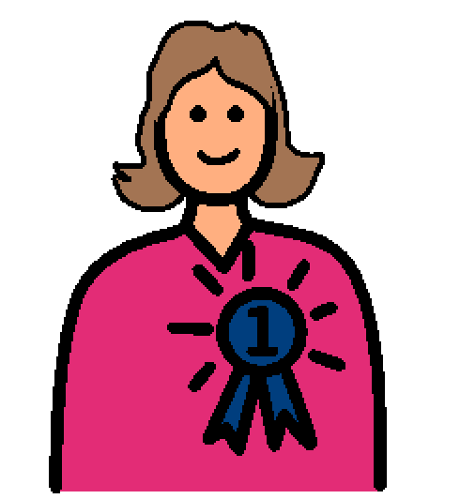 | I may get a prize.
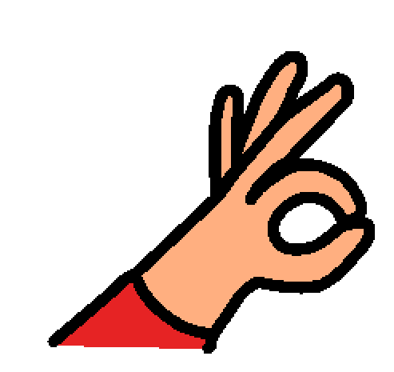 | If I do not get a prize, that will be OK.
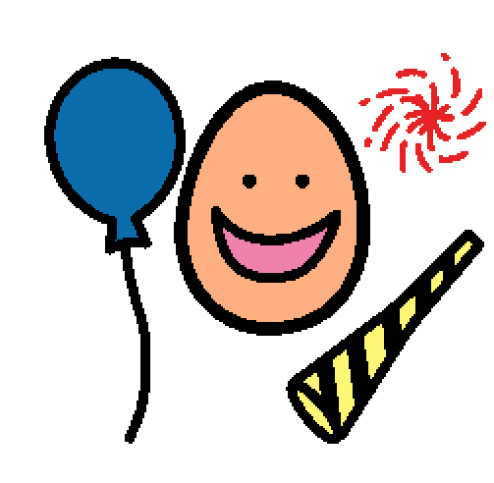 | My friends will have fun. I will feel happy watching them have fun at my party.
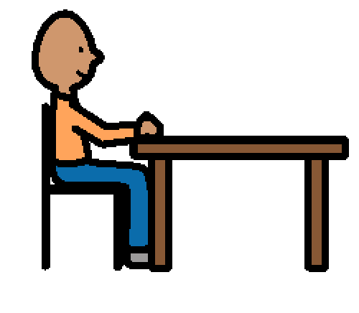 | When my parent tells me, I will sit at the table.
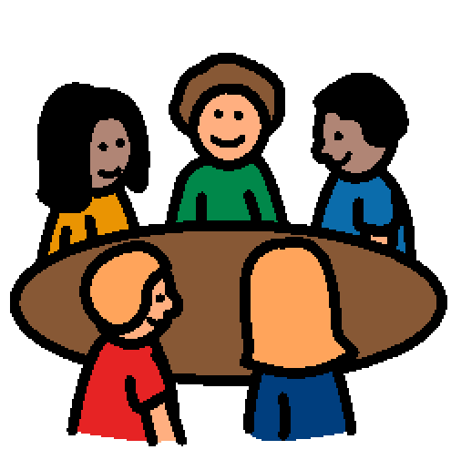 | Everyone will sit down.
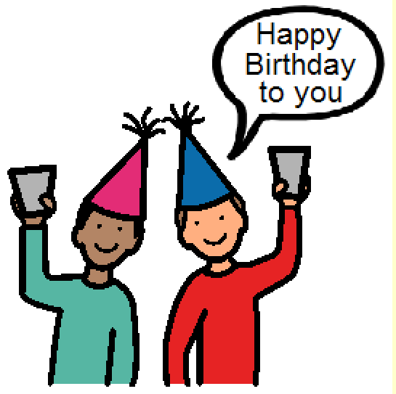 | All the children will sing Happy Birthday to me.
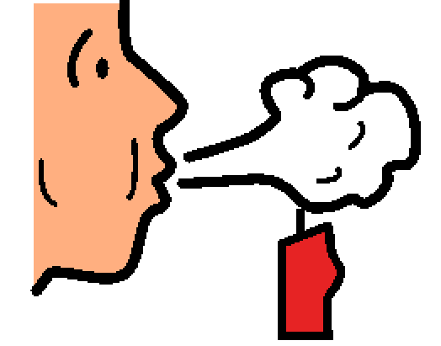 | I will blow out the candles on my cake. Everyone will clap.
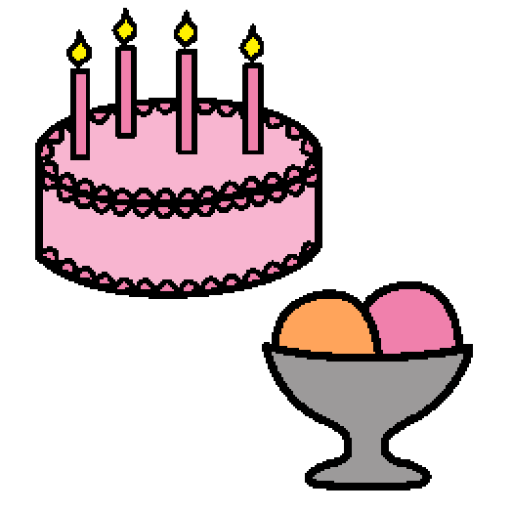 | We will all eat cake and ice cream.
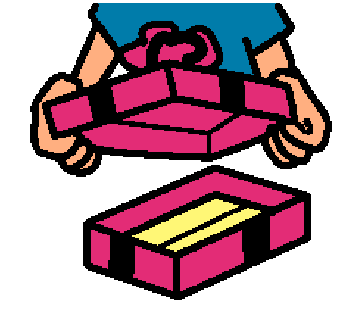 | After we have eaten, I will open my presents.
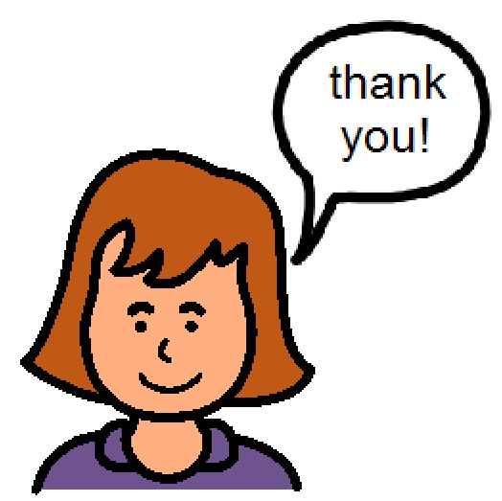 | I will tell each child “Thank you” after I open their gift.
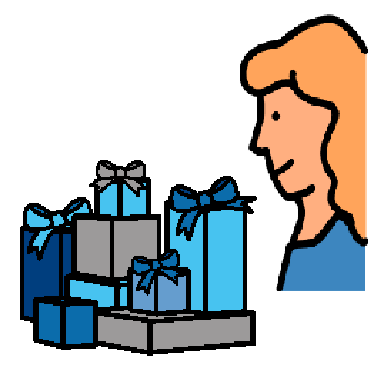 | The presents are mine, but some of the other children may want to look at them or play with them.
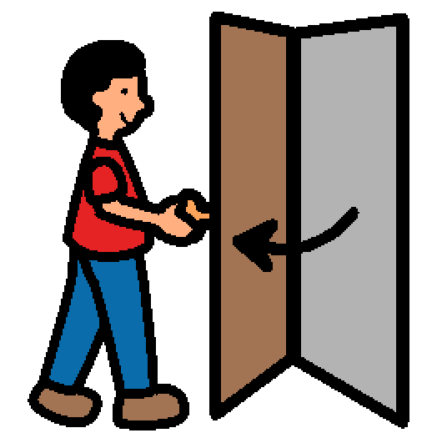 | When it is time for everyone to go home, I will open the door for them and thank them coming and for their presents.
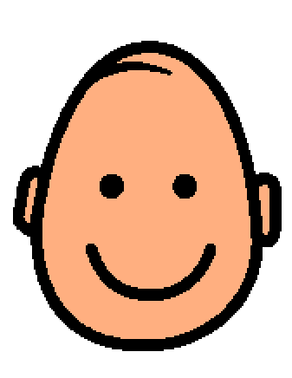 | I will feel happy because we had such a good time.

