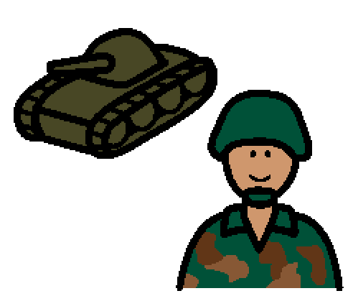 | My Dad is a soldier. He has a very important job.
 | Sometimes his job asks him to go away from home.
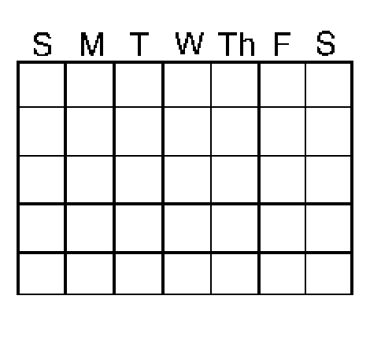 | Sometimes he is gone for a few days. Sometimes he is gone for months.
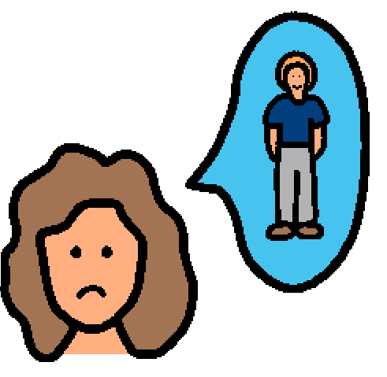 | I miss him when he is gone.
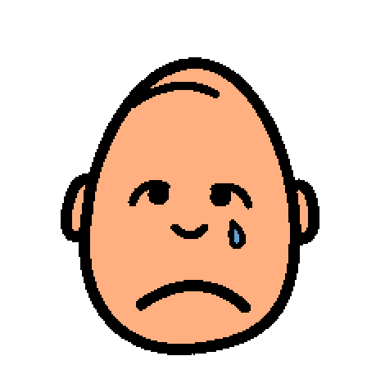 | Sometimes I get sad when Dad has to leave. That is OK.
 | Dad is sad to leave me too. It is OK to be sad.
 | Sometimes I get angry when Dad goes away because I want him to play with me.
 | That is OK. When I get angry or sad, I will try to write Dad a letter or draw him a picture.
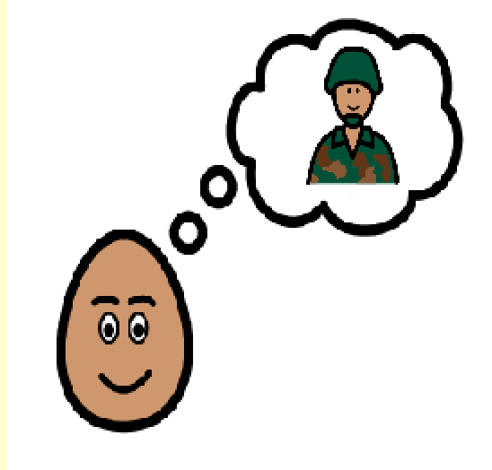 | That will help me remember Dad and feel like he is closer to home.
 | That will make me feel better.
 | I know Dad loves me even when he’s not here.
 | I know Mom loves me too.
 | I will try to be brave when Dad is not here.
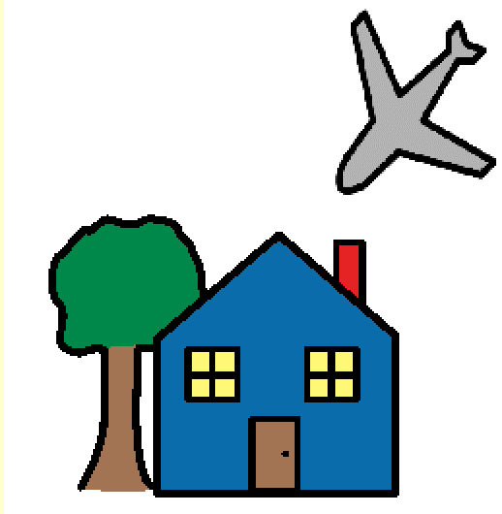 | I will look forward to Dad coming home.

