 | It is time for the holiday season and my class is going to do a Holiday Program at school. There are programs at school to celebrate holidays like Christmas.
 | A Holiday Program is kind of like a play or a live movie. Some students speak, some students act, and some students sing. My class is going to sing the songs we have been practicing in class.
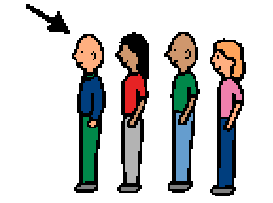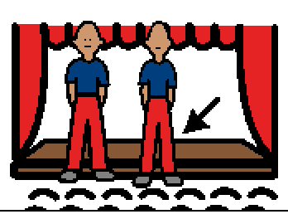 | When it is time for my class to be on stage, my class will line up and then walk on the stage. I should try to walk quietly and stay in line with my class. I will stand in the row next to my friends.
 | I should try to face the people watching. They are happy to see and hear us sing. I should keep my hands to myself and stand as quietly as I can. I am supposed to sing with my class but I am not supposed to talk to my friends when I am on the stage.
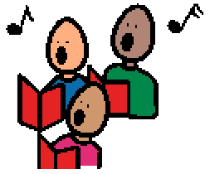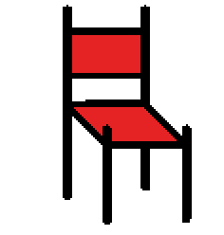 | If I do not want to sing, I can just stand quietly and listen to my friends sing. When we are finished singing we will go back to our seats. Other classes and students will sing and act too. I should try to sit quietly and listen to them sing and act. That will make them feel happy.

