Object Schedule Staff List
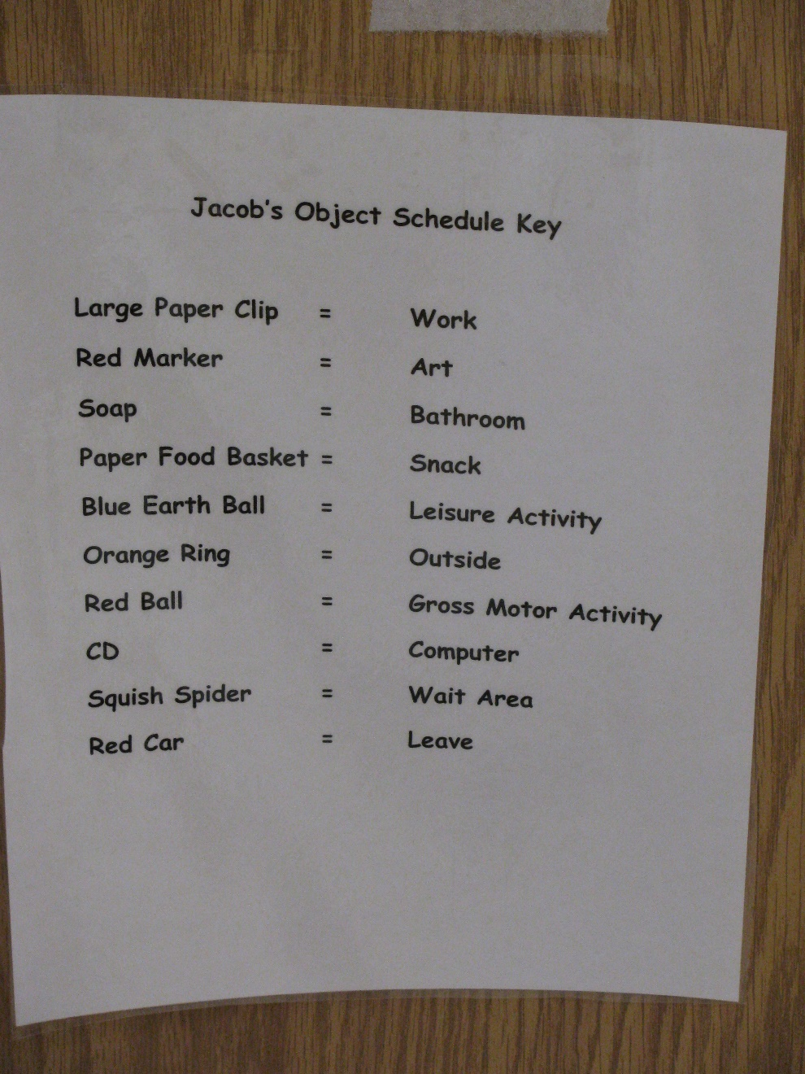
Category: Schedules
Description: This list is posted on the wall for staff to see which object to hand the student to tell him to go to the next activity.

