Object Schedule
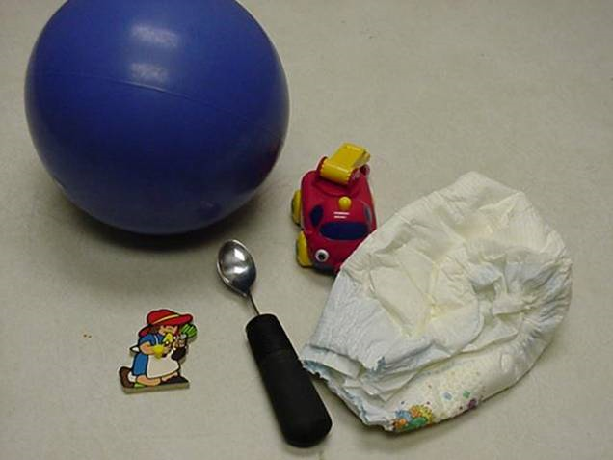
Category: Schedules
Description: One object is handed to student to tell him to move to the next area. Written list of all the objects that represent each area is posted on wall for staff. Function: independent transitioning.

