Picture Match Schedule
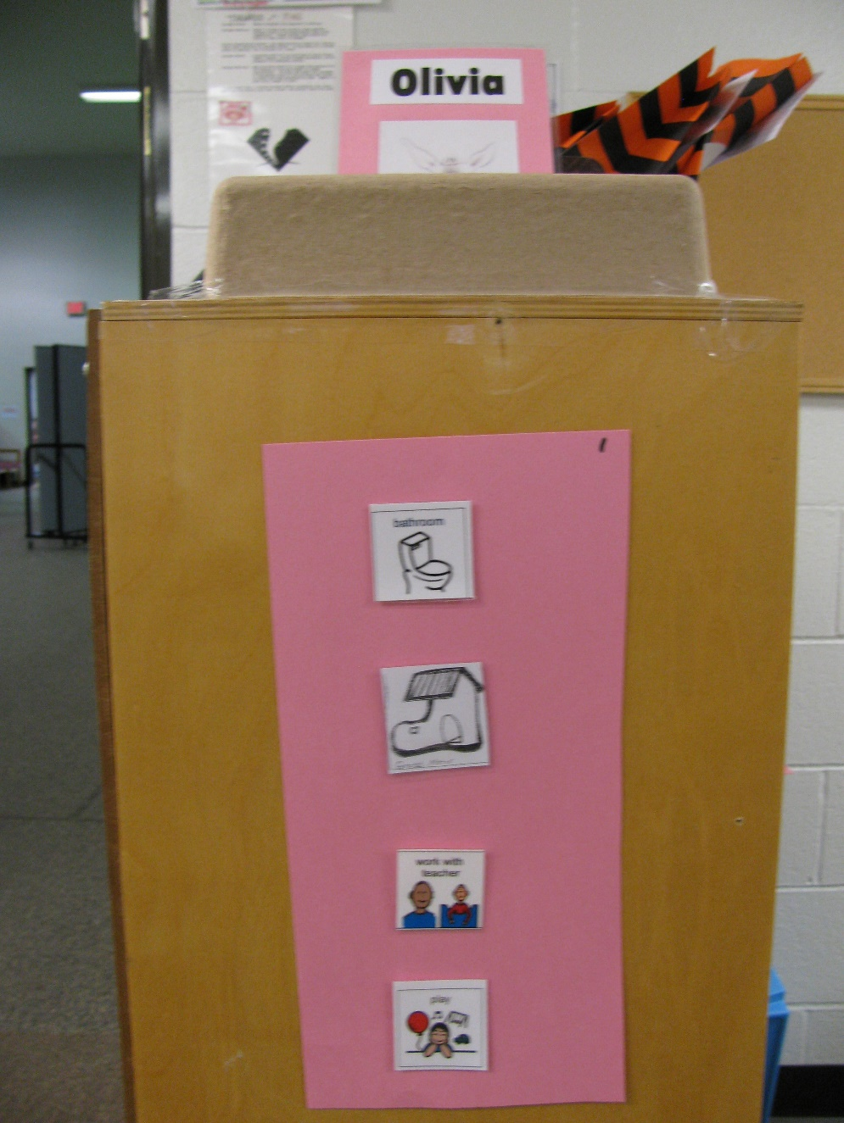
Category: Schedules
Description: Student is handed her name card that she matches and places in the box above her schedule. She then takes the first picture and matches it to an identical one in the area she is going. Function: independent transitioning.

