Plan for When I Have My Period
The medical word for period is menstruation. Some girls have their period every 21 days up to 28 days. I have mine every ___ days. I like to keep track on a calendar by counting the number of ___ days after my last period stops.
I like to keep track so I can have a plan in place for having my supplies with me. I keep a cosmetic bag with me in my backpack. Some girls use a purse. In my cosmetic bag, I carry extra pads and a pair of panties in case I get blood on the panties I am wearing.
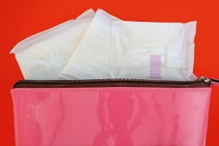
Some pads have wing or flaps on the side so that I can attach the pad to my panties. Some do not. Some women use a tampon instead of a pad. My plan is to start with a pad and later in life maybe use a tampon.
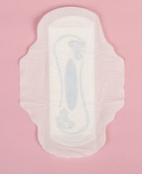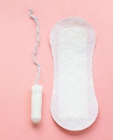
The pad comes in a ___ (add color) package. I open the package. Then unfold the pad. There is a strip of paper on the back side of the pad. I take this off and put this sticky side into my underwear. My caregiver may mark in my panties to guide me on where to put the pad.
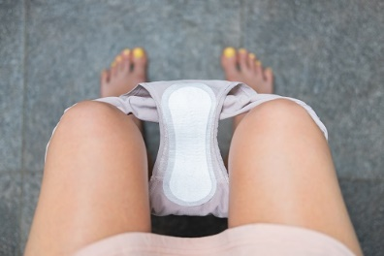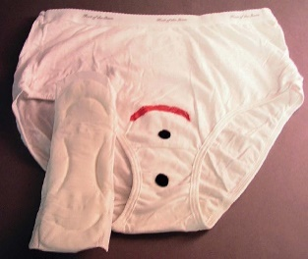
(Task Galore: For the Read World, 2004)
I check my pad every __ hours to see if it is full of blood to change it. If I am bleeding lightly, I can use an ultra-thin pad I have in the ____ wrapper. While I am sleeping, I use a maxi or super pad in the ____ wrapper so I can keep the pad in my panties overnight for 8 hours. I will try to learn the steps in being prepared for having my period.

