Pretend Real Picture Sorting
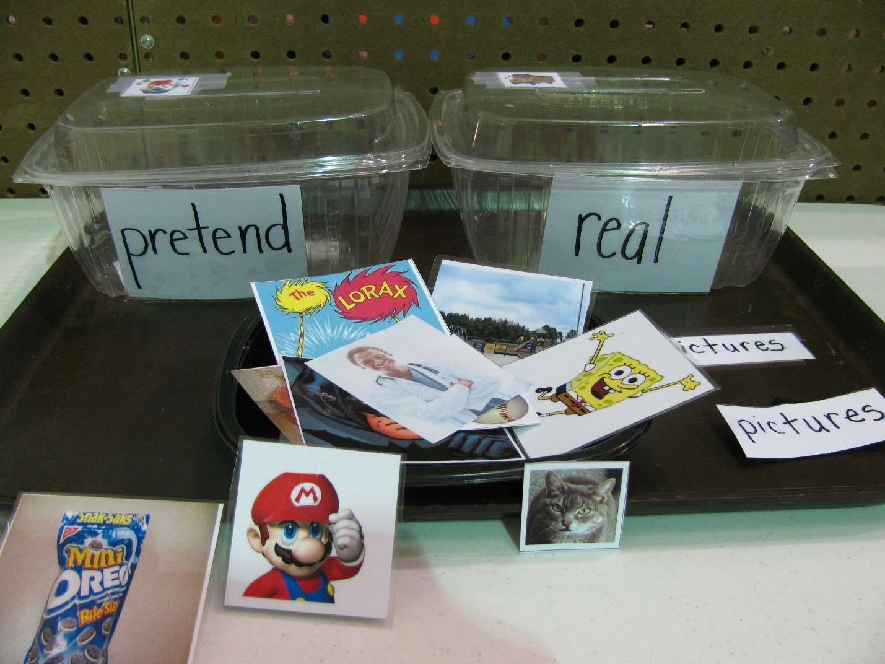
Audience: Educational professionals
Category: Structured Tasks
Description: One container is labeled ‘Pretend’ and one is labeled ‘Real’. Each is also labeled with a picture example of something real and something pretend. The containers are glued to the back half of a tray. In front of them on the tray is a third open container of pictures to be sorted. Student sorts the cards into the containers.
Function: To teach a student (who has difficulty understanding that TV shows are not real) the concept of ‘pretend’ and help them to know which things are pretend.

