Public and Private Spaces
There are private spaces and public spaces. All the spaces outside of my house are public spaces including the bus, my school, the gym, the park and many other spaces I have not listed. Most of the spaces in my house are public spaces like the living room, the kitchen, and the porch. The only completely private space for me is in my bedroom with the door closed.
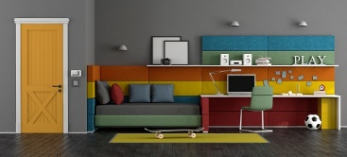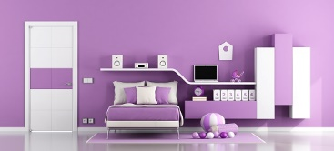
In my private space, I can close the door to have quiet time doing what I like to do without being interrupted. I have a sign on my door that says, “Please knock.”
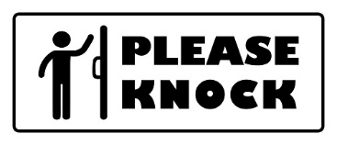
This sign means before someone in my house can come into my room, they must knock and then wait for me to say, “come in” before they can enter. I have a choice to say come in right away or if I need more time, I can say, “come back in ____ minutes”. If I need more minutes, then I will set a timer.
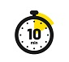
When my timer goes off, my private time is over. I must clean my space and open the door to let the person in my room. I can ask my family member for private time or I can add it to my schedule, so I know when I get private time every day. I will try to use my private time to do activities I want to do alone.

