Shaving Armpits: Do You Want To?
When I am a teenager, I will start to grow hair under my arms in the area where my arm connects to the side of my body. This is called my armpit. This hair will always be short.
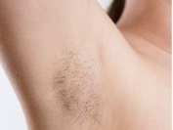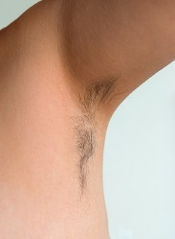
Most women shave the hair off their armpits, but some do not. It is a girl’s choice. I have talked it over with my parent or caregiver and we decided to shave my armpits. There are many types of shavers and all of them are sharp. As I learn to shave my armpits, my parent/caregiver will be with me to guide me until I know what to do independently. We decided, an electric razor is the safest way to help me from cutting myself.
Here are the steps:
Step 1: I raise my left arm in the air. I hold it up high in the air, so the skin is tight under my arm. If I have a rotary razor, I will shave in circles on my armpit. If I have a foil shaver, I will move it up and down on my armpit hair until the hair is gone.
Step 2: Then I will put my left arm down and switch to my right arm. Repeat steps 1 and 2.
Men usually do not shave the hair on their armpits; but some do. This is a choice for men too. Men shave their armpits in the same way that women do.

If I choose to shave the hair under my arm, I will do this often to keep my armpits clean.

