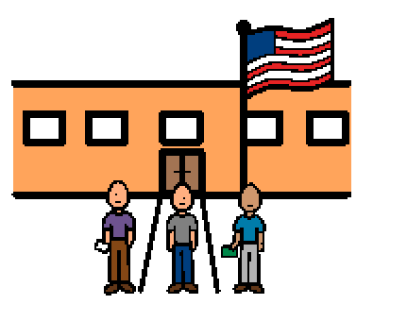 | Most of the time I go to school on Monday, Tuesday, Wednesday, Thursday, and Friday. Sometimes the schedule changes, and I don’t go to school.
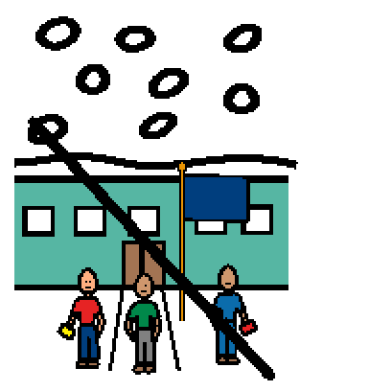 | Sometimes there are holidays or special days off. Sometimes there are snow days. There is no school on snow days.
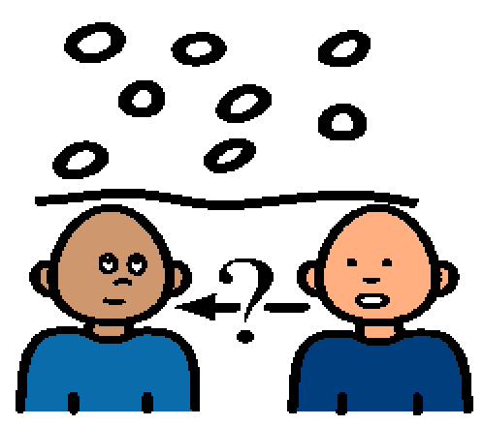 | Sometimes when there is a lot of snow, there is no school, and I will know the night before. I find out there is a snow day in the morning. Sometimes there is a lot of snow, but I will go to school.
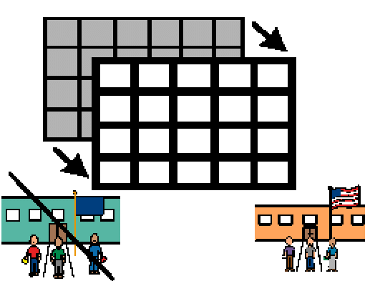 | I can ask my parents if there is school. My parents will tell me if it is a school day or a snow day. A snow day is a change in schedule, but that is okay.

