 | Most of the time I go to school on Monday, Tuesday, Wednesday, Thursday, and Friday.
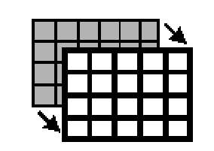 | Sometimes the schedule changes I do not go to school.
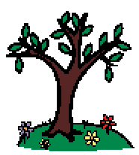 | Sometimes there are holidays and vacation days like Spring Break.
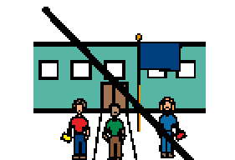 | There is no school during Spring Break. Spring Break is the last long break before summer.
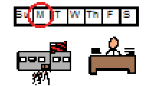 | I will go back to school on Monday. My teachers and friends will be happy to see me again!

