During puberty, I may grow taller. I will wear new clothes that fit.
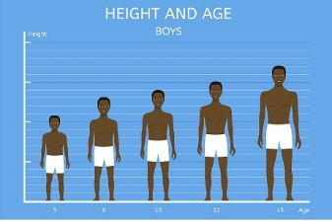

Hair will grow on my face, legs, arm pits, chest, and around my private parts.
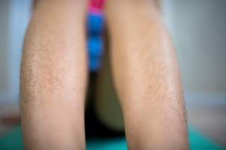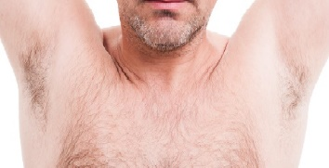
I will put deodorant on my arm pit so I can smell clean.
I may get acne.
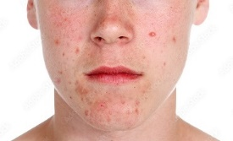
I will try to wash my face with soap and water one time a day.
I will try to wash my body and wear clean clothes every day. I will do my best to take care of my body during puberty to be healthy.

