 | Most of the time students go to school during the week. Students go to school on weekdays. We don’t go to school on Saturday or Sunday. Those days are called weekends. We don’t go to school on weekends, unless there is a special event. Sometimes we do not go to school when there is a holiday or a vacation.
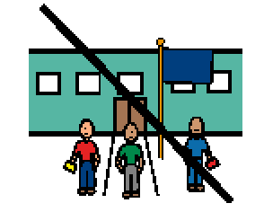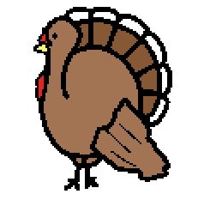 | We do not go to school on Thanksgiving Break. Thanksgiving Break is in November. Thanksgiving is a special time to spend with family and friends. Thanksgiving is a time to remember what we are happy about and thankful for. Thanksgiving is a holiday.
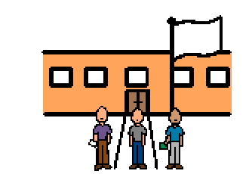 | We can look at the school calendar to remember the days when we do not go to school. There is no school during Thanksgiving Break, and we will go to school again on a Monday. Our teachers and friends will be happy to see us again. After Thanksgiving Break, we will have school on most days until Winter Break, unless there is a Snow Day.

