Visiting Friends and Family for the Holidays

I like to see my friends and family for the holidays. We might go to someone else’s house to have dinner. We might bring someone a present. When I go to someone’s house, it is important that I wear my mask. Wearing a mask is the way we can stay healthy and not get the coronavirus. It is important that I keep my mask and make sure it covers my mouth and nose.
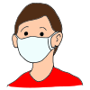
I can take my mask off when I have something to eat or drink. I will be careful not to get too close to someone else’s face when I do not have my mask on. I will cover my mouth if I need to sneeze or cough. I will also make sure to wash my hands. When I am finished eating or drinking, I will put my mask back on.
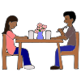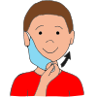
Another thing I can do to help everyone stay healthy is to not stand or sit too close to someone. This called social distancing. I can bump elbows with someone to say hello or goodbye, but I should not hug a person.
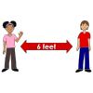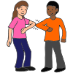
I can have a nice visit with my friends and family while I wear my mask and use social distance.

