Visiting Friends and Family for the Holidays

I like to see my friends and family during the holidays. We might go to someone else’s house to have snacks or dinner. We might bring someone a present. I can say “Happy Holidays” to greet people.
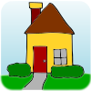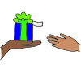
We may have snacks or a meal with my friends and family. If there is food that I do not like, it is polite to say, “No Thank you.” We might eat at a table. Sometimes people eat in the living room. I may sit on the couch, in a chair, or on the floor.
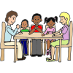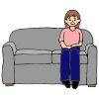
I can ask my parents if I can bring a favorite toy, book, or my iPad to play with. Before I play, I should first talk to my friends and family. I can tell them about my school or something I did on the weekend. People like to talk to me. It is nice for me to listen to the stories they want to tell me. Sometimes people play games together. When I want some time by myself, I can ask my parents if it is okay to use my iPad, read my book, or play with my toy.
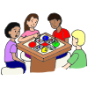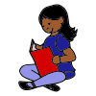
I can have a nice visit with my friends and family during the holidays!

