Wearing Deodorant
The armpit is a place where boys and girls sweat. During puberty, the sweat glands make more sweat that can leak through my shirt and often smells bad.
Before I get dressed, I need to wash with soap and water daily to keep my armpits smelling clean. I can use deodorant which will hide the body odor. Or I can wear an antiperspirant which not only makes the body odor smell better but also reduces the sweat. There are many kinds to choose from. Here are a few to try.
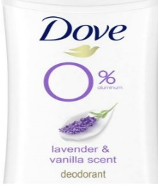
Some deodorants have a sweet smell while others smell like musk, and some don’t have a smell. I can choose the smell I like the best. Deodorants come in a spray, roll on, or gel form. I will try several kinds to find the one I like best. To put on deodorant, I raise my arm over my head. With the other hand, I hold the deodorant and rub it into my armpit from the top to the bottom 3 times. Then I switch arms to do the other side.
Then I put on a shirt and finish getting dressed. I will try to remember to put on my deodorant every day to smell fresh and sweat less.

