 | Sometimes I feel angry.
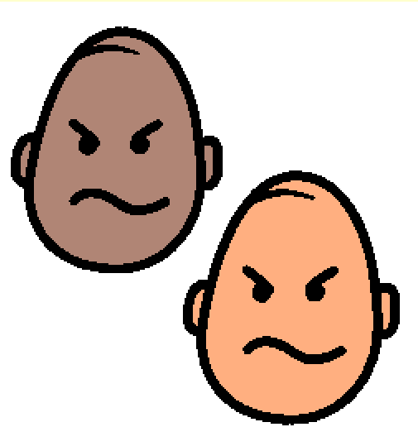 | All people feel angry at one time or another.
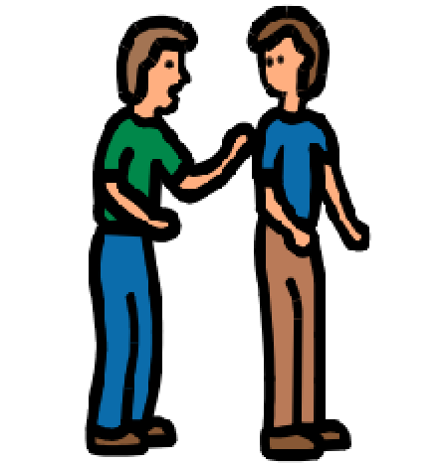 | When I get angry I will find my teacher, Mom, Dad or another adult.
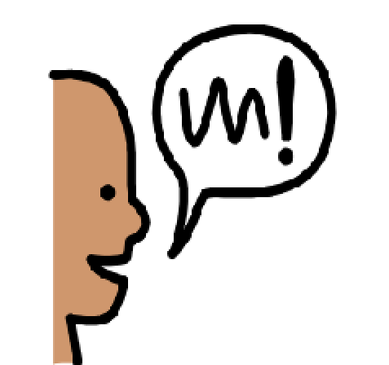 | When I find them I will try to use words to tell them that I am angry.
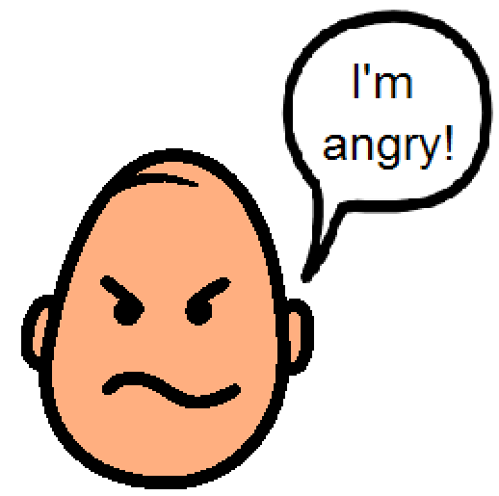 | I can say “I’m angry!” or “That makes me mad!“
 | It is O.K. to use words when I feel angry.
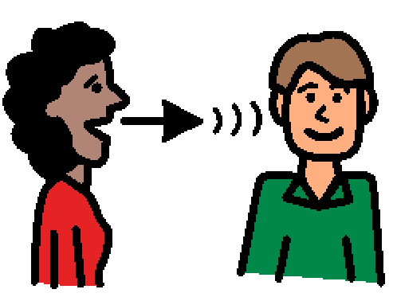 | They will talk to me about what happened and how I feel. This might help me to feel better.
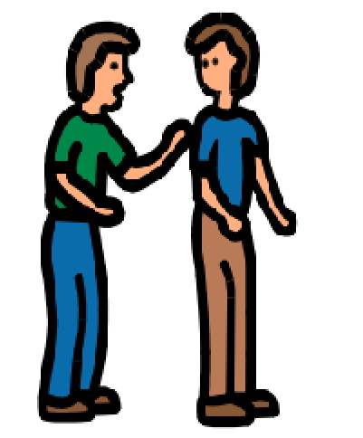 | Wherever I am I can try to find someone to talk to about how I feel.

