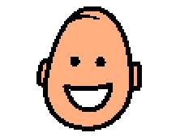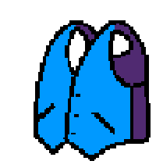 | Sometimes people like to do things that make them feel good, like playing with their favorite toy or eating their favorite food. Sometimes people do things that make them feel calm. One way to feel calm is to wear a special vest. Some vests have weights that tell the body and brain to calm down. Some vest are made to squeeze, like a hug. Squeeze vests tell the body to calm down too.
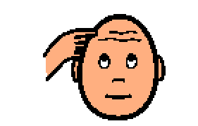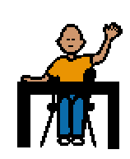 | I wear a special vest that tells my body and brain to calm down. My body and brain feel better when I wear a vest. I can think about what I am supposed to do better. I can do my work better. I can watch and listen and learn better. My vest helps my body and brain to be calm.
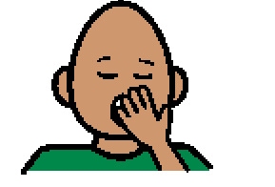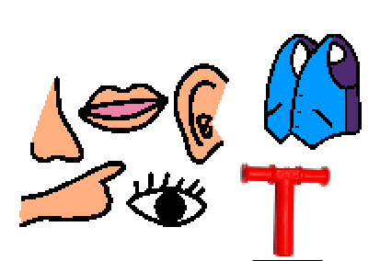 | If I get sleepy or feel too heavy in my vest, I can take a break from wearing it. I need to ask an adult to help me take it off. I remember that it is a good idea to wear my vest. If I feel too excited and I can’t think or watch or listen or learn. I can ask for help putting my vest on. My vest helps my body and brain to be calm. My vest is one of my sensory tools that helps me to learn and play better.

