Word Match Interest Schedule
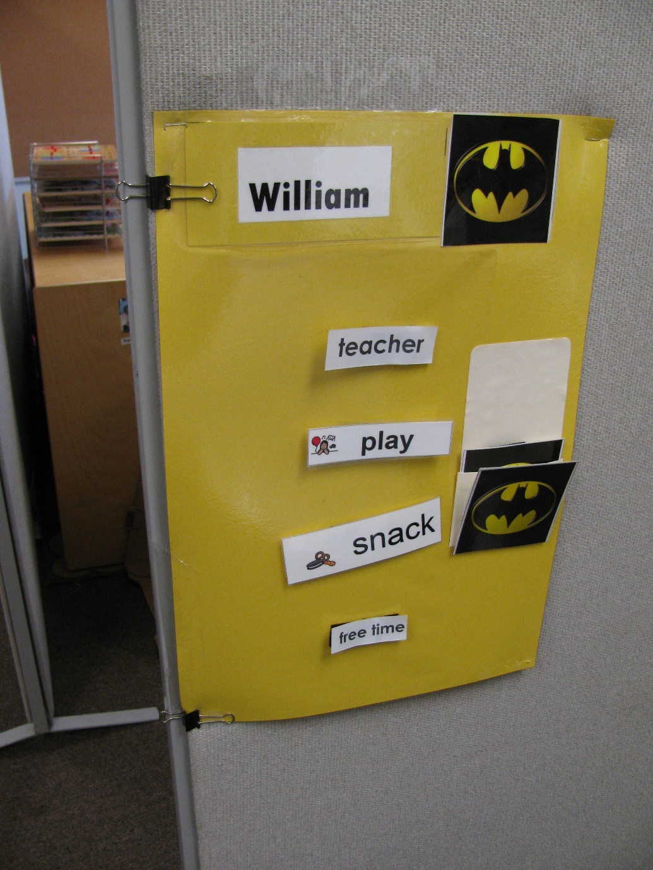
Category: Schedules
Description: Movie interest picture is handed to student- student matches it to the symbol on the pocket on the schedule. Then student pulls off top word and matches it to an identical word in the area he is going to. Function: independent transitioning.

