Word Match Schedule
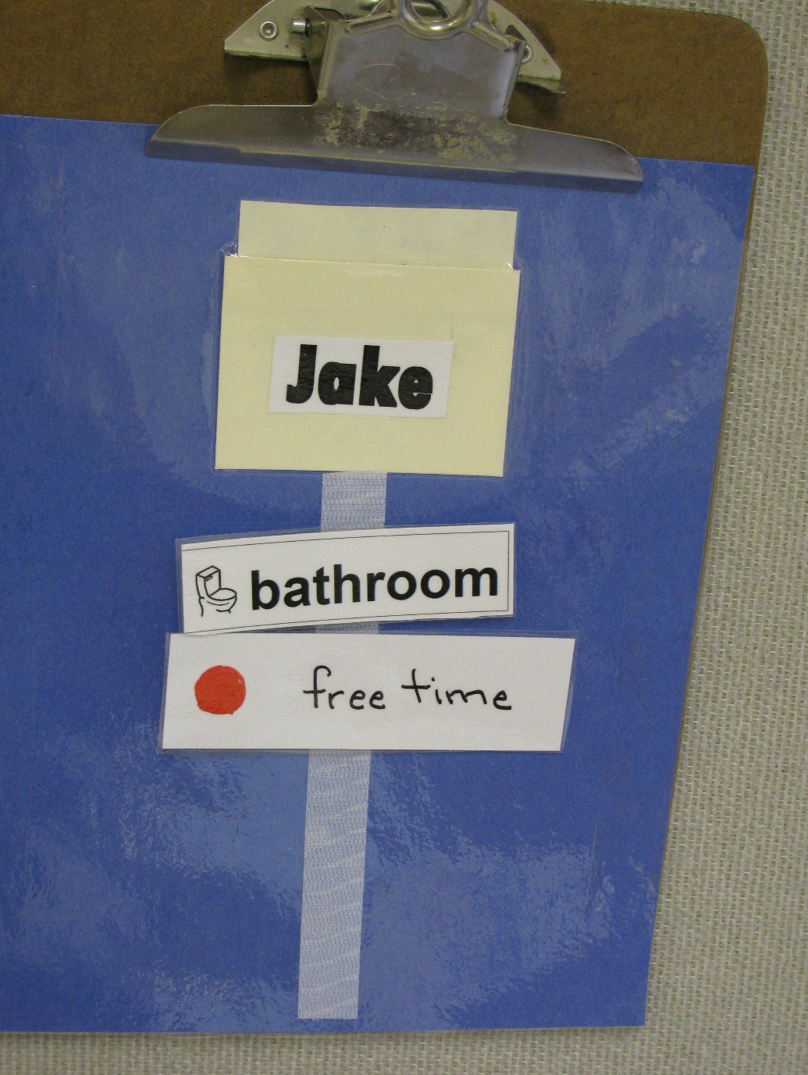
Category: Schedules
Description: Name card is handed to student- student matches it to his name on the pocket on the schedule. Then student pulls off top word and matches it to an identical word in the area he is going to. Function: independent transitioning.

