Written Wipe Off Clipboard Schedule
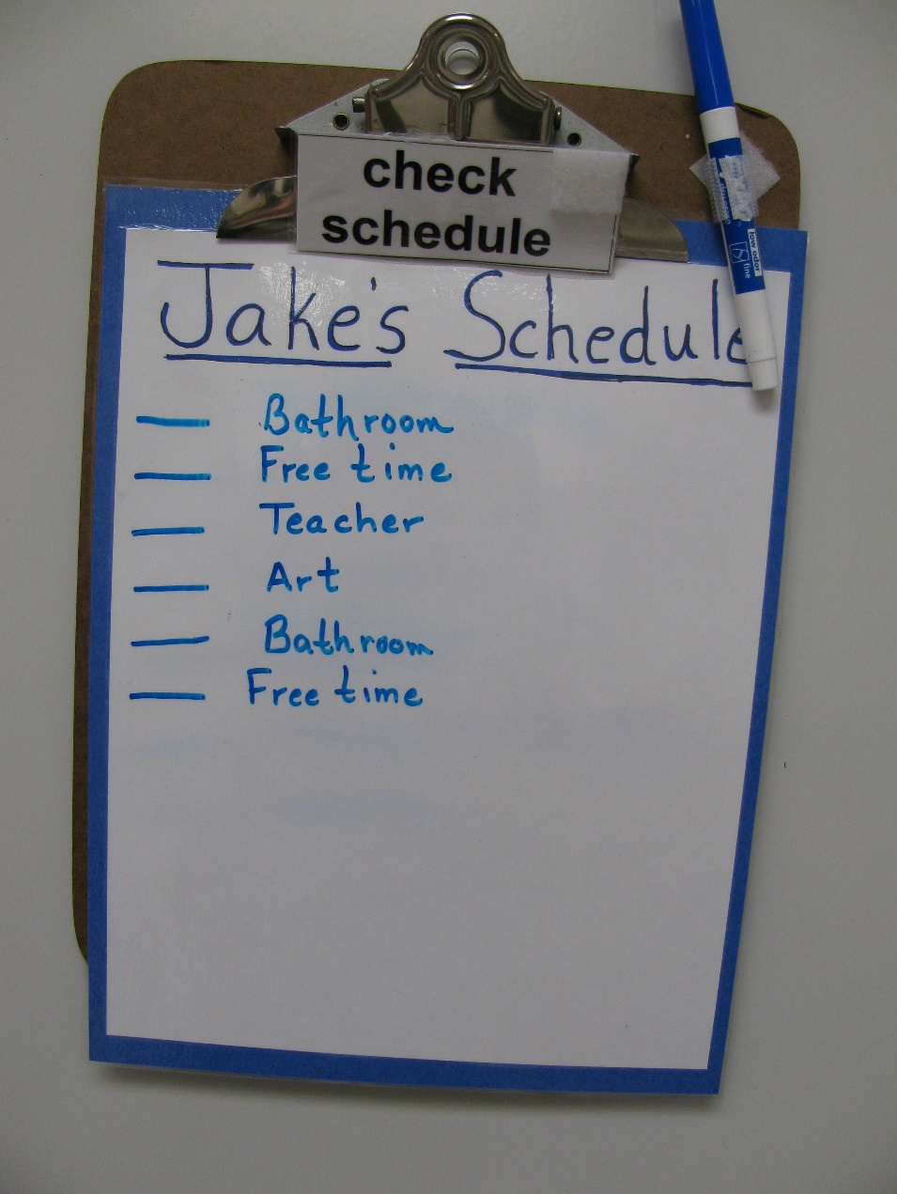
Audience: Educational professionals, parents, community support professionals
Category: Schedules
Description: Daily activities written on wipe off list on clipboard. Place for student to put ‘Check Schedule’ card at top of schedule. This card is handed to student or placed at the end of student work system (‘to do’ list). Marker allows student to check each item off as he completes them.
Function: To increase student independence and decrease resistance to transitions.

