Written Work System Elementary Student 1 of 2
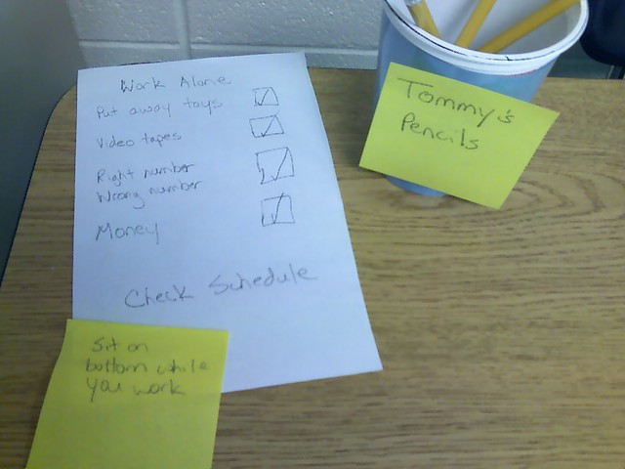
Category: Work Systems
Description: Written list of activities to be completed is placed on student’s desk. Student checks off each activity as he completes it.

