Written Work System for Adult 1 of 2
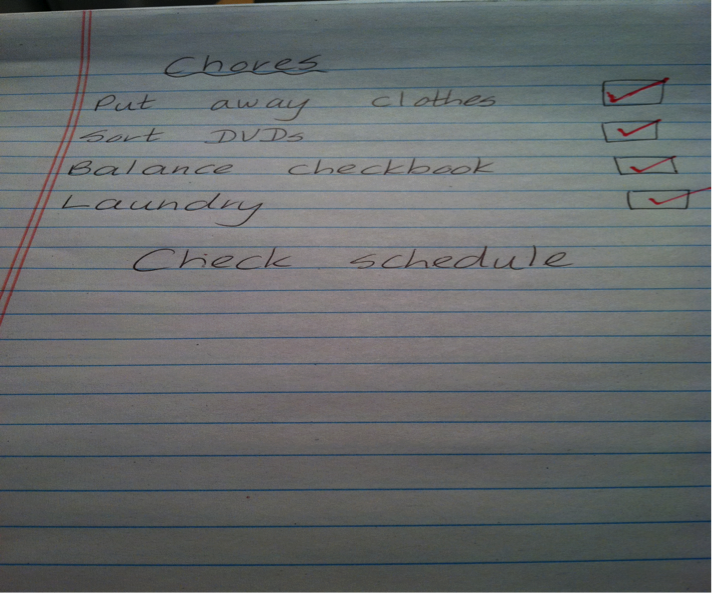
Category: Work Systems
Description: Written list of activities to be completed is placed on desk. Learner checks off each activity as he completes it.

